29th JULY, 2024

AN ANALYSIS ON VERTEX MOBILE NET. CHURN

AUTHORED BY:

IWUJI GLORY EBUBECHUKWU

GROUP 3

**TABLE OF CONTENTS**

* **Introduction**
* **Data Preparation**
* **Dashboard Design and Features**
* **Key Insights**
* **Recommendations**
* **Conclusion**

**INTRODUCTION**

**Project Objective:** Conduct a thorough examination of Vertex Mobile Net's telecom data to determine the factors contributing to customer churn and devise effective strategies for reducing churn and boosting customer retention.

The dashboard will highlight key deliverables such as Total number of customers, total number of churned customers, the percentage churn rate, reason for churning, contract type, unlimited data plan, age group, account length, gender distribution, International plans and calls, State, and customer service calls.

**Data Preparation:**

* **Data Source:** The data used in this analysis; *VERTEX MOBILE NET. DATA* was provided by **Only Quality Data.**
* **Metadata:**

1. **Customer ID:** The unique ID that identifies a customer
2. **Churn Label:** Contains “Yes” or “No” to indicate if a customer churned’
3. **Churn Reason:** The particular reason why the customer ended the contract.
4. **Churn Category:** Groups multiple churn reasons together for analysis purposes.
5. **Gender:** The gender of the customer, indicated by “Male”, “Female”, or “Prefer not to say”.
6. **Under 30:** Indicates if the customer is under 30 with “Yes” or “No”.
7. **Senior:** Indicates if the customer is 65 or above with “Yes” or “No”.
8. **Age:** The age of the customer.
9. **Contract Type:** Contains “Month-to-Month”, “One Year” or “Two Year”
10. **Payment Method:**  Preferred payment method of the customer indicated with “Credit card”, “Direct debit” or “Paper check”.
11. **State:** The code of the state where the customer lives.
12. **Phone Number:** Phone number of the customer.
13. **Group:** Indicates if the customer is part of a group contract.
14. **Number of customers in a group:**  Number of customers part of the group.
15. **Account length (in months):** The number of months a customer has been with Vertex
16. **Local calls:** Amount of local calls (within the US) from the customer
17. **Intl. calls:** Amount of international calls (outside the US) from the customer
18. **Intl. Mins:** The number of minutes spent calling internationally.
19. **Intl. Plans:** Indicates if the customer has a premium plan to call internationally for free with a “Yes” or “No”.
20. **Extra International Charges:** Contains the extra charges for international calls for customers who are not on an international plan.
21. **Customer Service Calls:** The number of calls made to customer service
22. **Avg Monthly GB Download:** Contains the average monthly download volume in gigabytes.
23. **Unlimited Data Plan:** Indicates if the customer has free unlimited download capacity with “Yes” or “No”.
24. **Extra Data Charges:** Contains the extra charges for data downloads for customers who are not on an unlimited plan.
25. **Monthly Charges:** Average of all monthly charges to the customer.
26. **Total Charges:** Sum of all monthly charges.

* **Data Cleaning:** The data was loaded to power query in Microsoft Power BI where the data types for each column was checked and verified.
* **Data Preparation:** With regards to data transformation, to determine the age group of the churned customers and their churn rate, age(groups) was extracted. A DAX formula was also used to create new measures like the churn rate, churned customers and total customers.

**DASHBOARD AND DESIGN FEATURES**

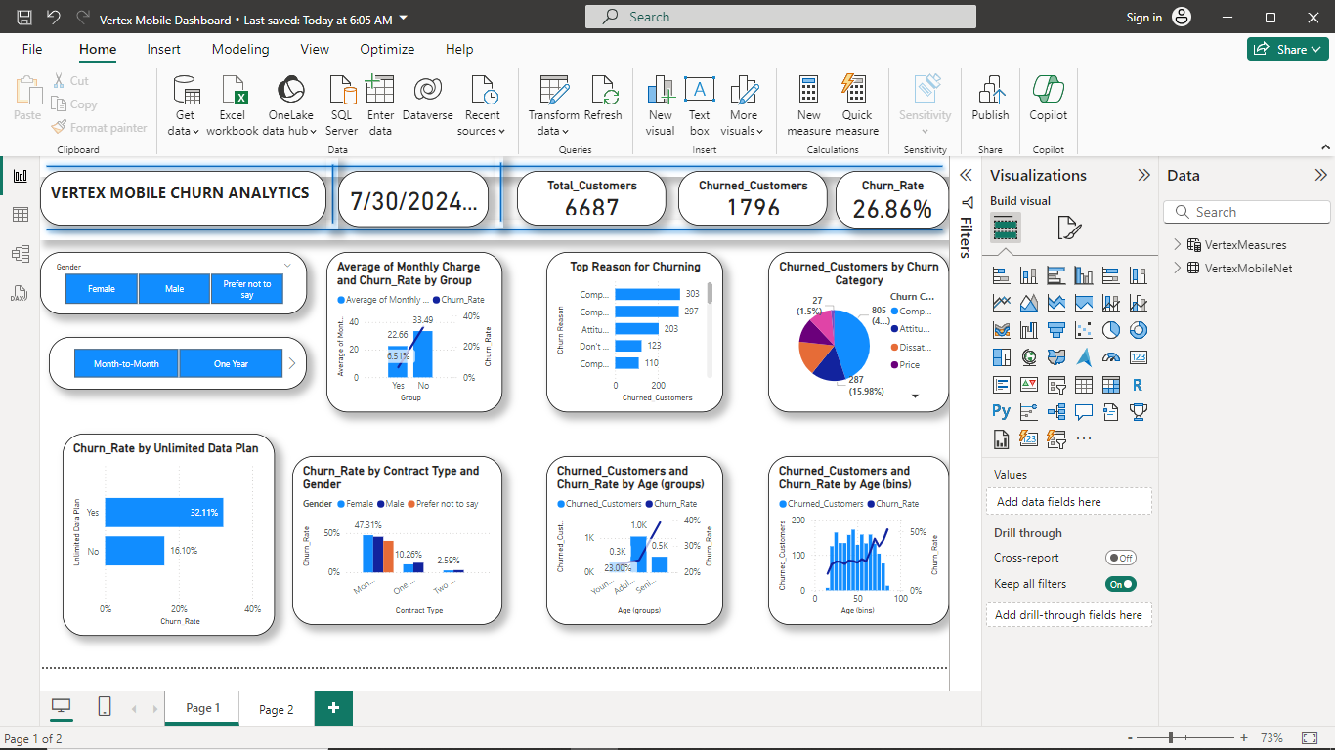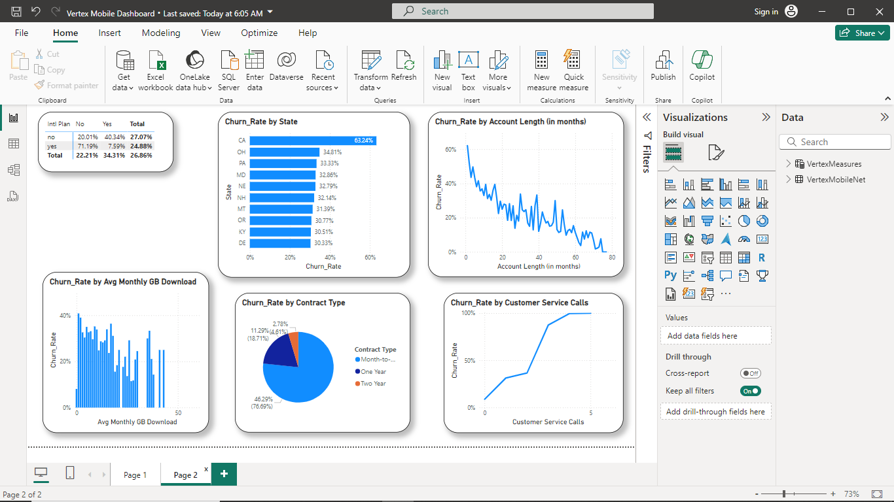

As earlier mentioned, the dashboard highlights key deliverables such as; metrics on:

* **Total customers:** The widget displays the total number of customers that uses vertex mobile.
* **Churned Customers:** This widget also displays the count of the churned customers. This is essential for a quick understanding of the overall churned customers size.
* **Churn Rate:** This displays the percentage of churned customers compared to the total customers.
* **Average monthly plan and churn rate by group:** The line and clustered column chart displays the average of monthly plan and churn rate by group.
* **Top Churn Reason:** The top reason for churning displayed using a clustered bar chart showing the churn reason by the churned customers.
* **Churned Customers Category:** The pie chart displays the churned customers by their churn category.
* **Unlimited data plan:** The clustered bar chart displays the churn rate with respect to customers with unlimited data plan.
* **Contract type and gender:** The clustered column chart displays the churn rate by the customers contract type and their gender
* **International Plan:** The matrix indicates the percentage of customers who are on international plan and make international calls.
* **Account length of churned customers:** The line graph displays the churn rate of customers by their account length
* **Customer service calls:** The line graph indicates the churn rate of customers with respect to the customer service calls
* **State:** This displays the churn rate of customers by their state.

**KEY INSIGHTS**

* Vertex Mobile Net. has a total of 6687 Customers.
* The total number of churned customers is 1796 and the churn rate is 26.86%.
* The prevalent churn category is the Competitor category with a percentage of 44.82%.
* The top reason for churning is because competitors made more offers while the least reason is because of death.
* Churned customers within the age group of 30-65 has the highest churn rate.
* Customers that are part of a group have a lower phone bill of 22.66 which result in a lower churn rate of 6.51% compared to those that are not part of a group.
* Customers with monthly contract type have the highest churn rate with the female having the highest churn rate of 47.31% followed by the male 45.31% while 40% was for those who prefer not to say their gender.
* Customers with unlimited data plan has the highest churn rate of 32.11% compared to those without unlimited data plan (16.10%).
* Customers who are not on an international plan have a higher churn rate compared to those on international plan. Also, The churn rate of those who have made international calls is higher than that of those who haven’t made an international call.
* New customers have a higher churn rate compared to old customers.
* The state with the code CA has the highest churn rate of 63.24%.
* As the customer service calls increases, the churn rate also increases.

**RECOMMENDATIONS**

1. **Address Competitor-Driven Churn**:
   * **Enhanced Offers**: Develop competitive offers and loyalty programs specifically targeting customers who competitor promotions may entice.
   * **Marketing Campaigns**: Launch targeted marketing campaigns highlighting the unique benefits and value of Vertex Mobile's services compared to competitors.
2. **Improve Onboarding and Customer Experience**:
   * **New Customer Engagement**: Implement a robust onboarding program for new customers, including personalized welcome messages, tutorials, and check-ins during the first few months to ensure they are satisfied and understand the benefits of their plan.
   * **Customer Service Excellence**: Invest in training customer service representatives to provide exceptional support, with a focus on quick and effective resolution of issues to reduce churn related to service calls.
3. **Target High Churn Groups with Specific Strategies**:
   * **Monthly Contract Customers**: Given the high churn rate among customers with monthly contracts, consider offering incentives for switching to longer-term contracts, such as discounts or additional benefits.
   * **Unlimited Data Plan Users**: Review the pricing and benefits of the unlimited data plan to ensure it meets customer needs. Consider offering flexible data plans or additional perks for unlimited plan users.
4. **Leverage Group Plans to Reduce Churn**:
   * **Promote Group Plans**: Increase awareness and adoption of group plans, highlighting their cost savings and lower churn rates. Offer special promotions for group plan enrollments.
5. **Enhance Plans for International Callers**:
   * **International Plan Benefits**: Promote the benefits of the international plan to customers who make international calls. Ensure that the pricing and features of these plans are attractive and competitive.
6. **Regional Focus and Customization**:
   * **State-Specific Initiatives**: Develop targeted retention strategies for states with high churn rates, such as CA. This could include localized offers, improved service coverage, and tailored customer support.
7. **Loyalty Programs and Long-Term Benefits**:
   * **Loyalty Rewards**: Introduce loyalty programs that reward long-term customers with discounts, exclusive deals, or additional services, encouraging them to stay with Vertex Mobile.
8. **Proactive Churn Management**:
   * **Predictive Analytics**: Implement a churn prediction model to identify at-risk customers early. Use predictive analytics to proactively engage with these customers and address their concerns before they decide to leave.
   * **Regular Feedback Collection**: Conduct regular surveys and feedback sessions to gather insights from customers about their experiences and areas for improvement.
9. **Optimize Customer Service Interaction**:
   * **Follow-up Protocols**: Establish follow-up protocols for customers who have contacted customer service multiple times to ensure their issues are fully resolved and their satisfaction is restored.
10. **Plan Customization and Flexibility**:
    * **Tailored Plans**: Offer more flexible and customizable plans that can adapt to the changing needs of customers, especially those in high churn categories.

### CONCLUSION

The analysis of Vertex Mobile's churn data reveals critical insights into customer behavior and the factors driving churn. With a churn rate of 26.86%, it is evident that competitive offers, customer service issues, and specific plan features significantly impact customer retention. Addressing these issues through targeted retention strategies, personalized customer engagement, improved customer service, and flexible plan offerings can substantially reduce churn. By focusing on high-risk segments and implementing proactive churn management practices, Vertex Mobile can enhance customer satisfaction and loyalty, ultimately leading to a more stable and thriving customer base.